**EV Charging Demand Forecasting Project Report**

**1. Abstract**

This project aims to analyze and forecast the electricity demand at EV charging stations. By combining EV usage data with weather and traffic data, we identify demand patterns. Time-series models such as ARIMA and Prophet are applied for forecasting, while visualization (heatmaps, line charts, Tableau dashboards) provides actionable insights for infrastructure planning.

**2. Introduction**

With the rapid adoption of Electric Vehicles (EVs), the need for efficient charging infrastructure has grown significantly. Proper demand forecasting ensures optimal placement of charging stations, balanced energy loads, and enhanced customer experience. This project focuses on analyzing hourly demand data across cities and using machine learning models for demand prediction.

**3. Tools Used**

* **Python**: Pandas, Numpy, Matplotlib, Seaborn for data preprocessing and visualization
* **Machine Learning Models**: ARIMA, Prophet for time-series forecasting
* **Tableau**: For creating interactive dashboards
* **Excel**: For initial data cleaning and extraction

**4. Steps Involved in Building the Project**

**Step 1: Data Collection & Cleaning**

* Merged EV usage data with weather data
* Removed missing values and standardized column names

**Step 2: Feature Engineering**

* Derived time-based features (hour_of_day, day_of_week, is_weekend)
* Created lag features (lag_1, lag_24) and rolling averages

**Step 3: Visualization**

The following charts were generated to understand demand patterns:

## Heatmap (Demand by Weekday & Hour)

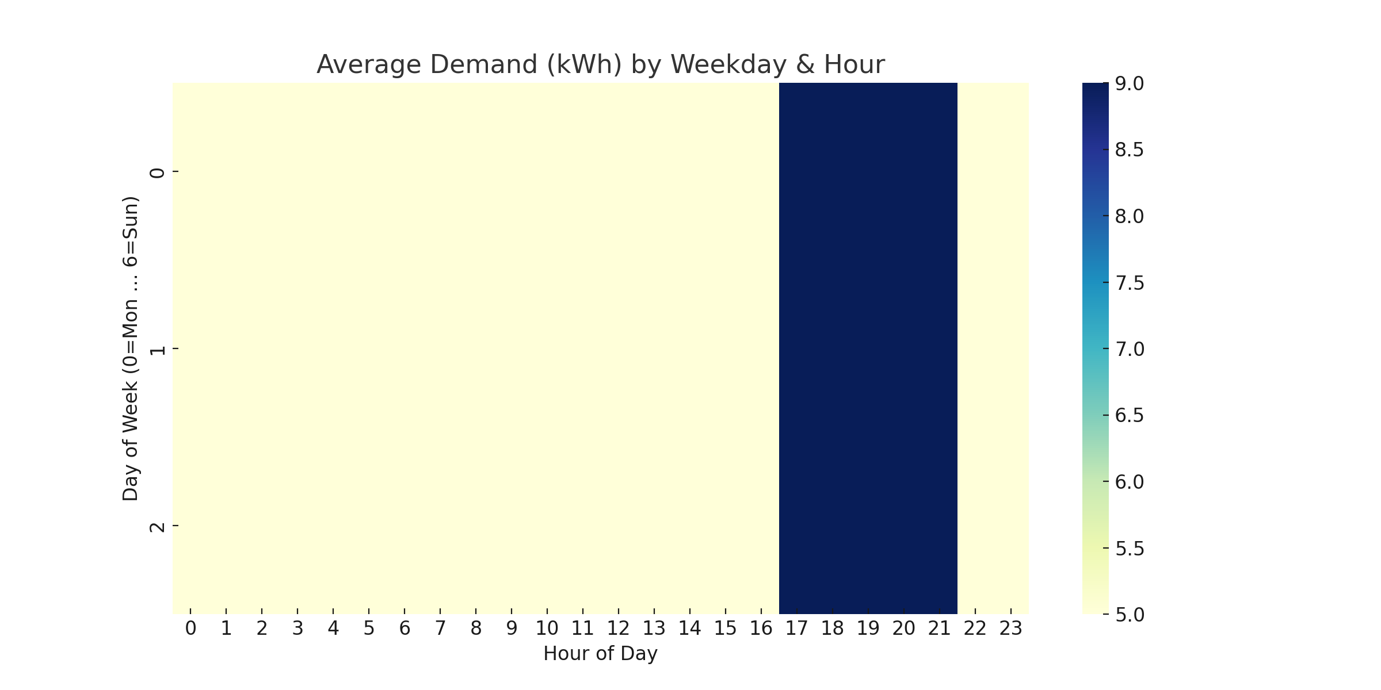

The heatmap shows how EV charging demand varies across weekdays and hours of the day.

## Line Chart (Average Hourly Demand)

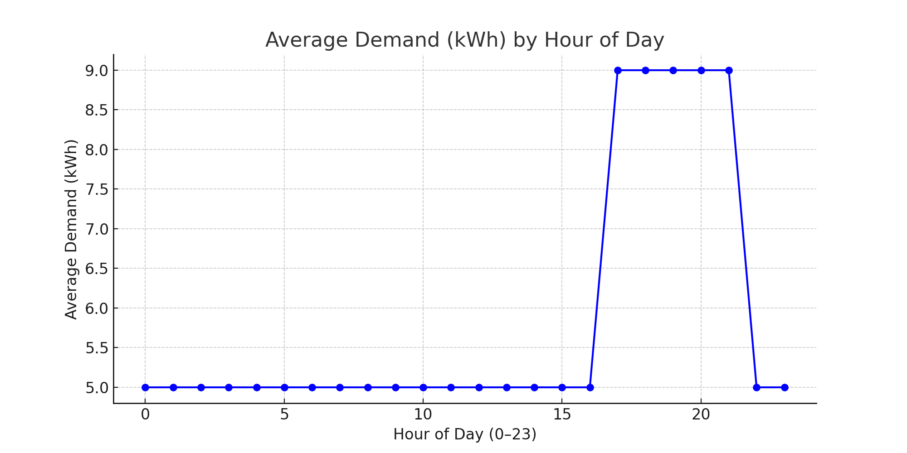

The line chart displays the average EV charging demand across different hours of the day.

* Heatmaps for weekday × hour demand patterns
* Line charts for daily average demand

**Step 4: Modeling**

* Applied ARIMA/Prophet for demand forecasting
* Evaluated models using RMSE and MAE

**Step 5: Dashboarding**

* Built interactive Tableau dashboards to show demand trends and insights

**5. Conclusion**

The project successfully demonstrates how EV charging demand can be forecasted using data-driven approaches. Feature engineering highlighted demand drivers, visualizations revealed usage trends, and time-series models provided accurate forecasts. These insights can help city planners and energy providers optimize charging station deployment. Future improvements include real-time integration of traffic and weather feeds for dynamic forecasting.